Predictive Modelling and Risk Scoring for Bank Customer Churn

Abstract
Customer churn has become a major concern in the banking industry as it directly impacts profitability, customer retention, and long-term business sustainability. With increasing competition and customer expectations, banks require proactive systems capable of identifying customers likely to discontinue their relationship before actual attrition occurs. Traditional churn analysis methods are often reactive and limited in predictive capability. Therefore, this study proposes a machine learning-based predictive churn intelligence system for retail banking applications.
The research utilizes customer demographic, financial, and behavioural data to predict churn probabilities and generate customer-level risk scores. Multiple machine learning algorithms including Logistic Regression, Decision Tree, Random Forest, and Gradient Boosting were implemented and comparatively evaluated. Various preprocessing techniques such as encoding, feature scaling, data validation, and feature engineering were applied to improve predictive performance. The models were assessed using Accuracy, Precision, Recall, F1-score, and ROC-AUC metrics.
Among all implemented models, Gradient Boosting achieved the best overall performance with an accuracy of 87% and ROC-AUC score of 0.87. To improve model interpretability, SHAP (Shapley Additive Explanations) analysis was conducted to identify major churn drivers including customer age, activity level, and product utilization. Additionally, a Streamlit-based interactive dashboard was developed to facilitate real-time churn prediction and risk assessment.
The findings demonstrate that machine learning and explainable AI techniques can significantly support proactive customer retention strategies and data-driven decision-making in the banking sector.

- Introduction
The banking industry has undergone significant transformation over the last decade due to rapid technological advancement, digital financial services, and changing customer expectations. Modern customers possess greater access to online banking platforms, fintech services, and alternative financial institutions, making customer retention increasingly challenging for traditional banks. In such a competitive environment, maintaining long-term customer relationships has become one of the most important strategic priorities for financial institutions.
Customer churn refers to the process in which customers discontinue their relationship with a bank by closing accounts, reducing financial activity, or switching to competing institutions. High customer churn rates can negatively impact profitability, operational stability, customer lifetime value, and long-term business growth. Studies in customer relationship management suggest that acquiring new customers is substantially more expensive than retaining existing ones. Consequently, banks must focus not only on customer acquisition but also on proactive retention strategies capable of minimizing attrition.
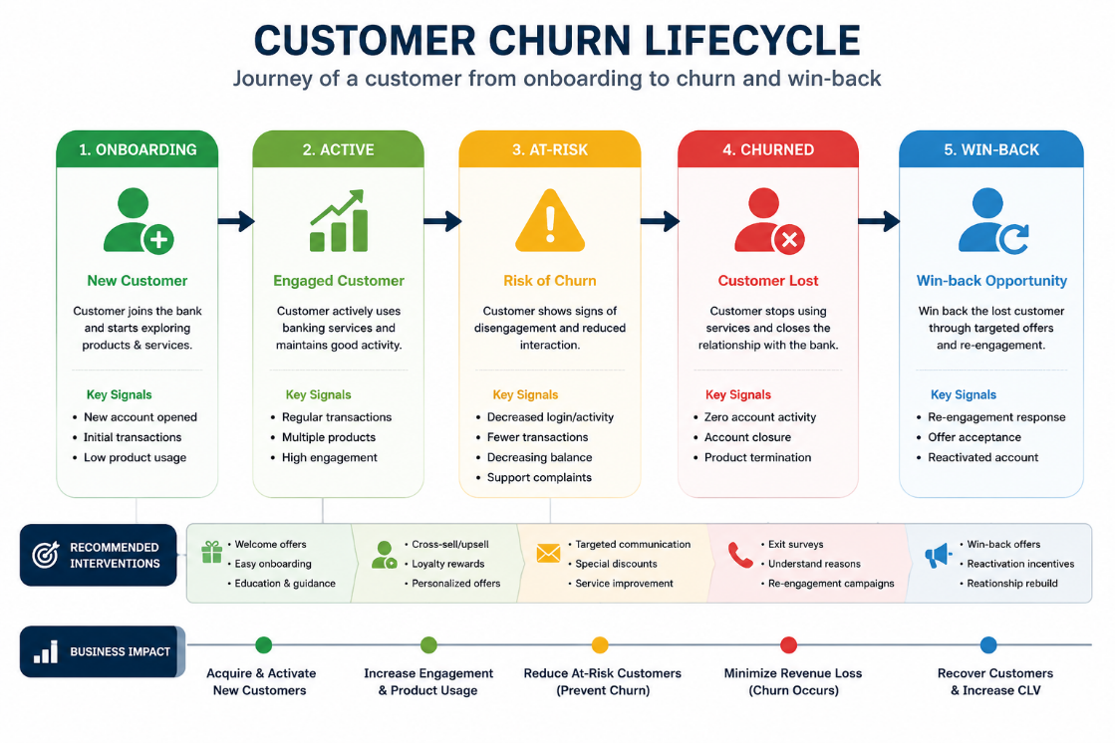
Traditional churn analysis approaches mainly rely on descriptive statistics and historical trend analysis to identify reasons behind customer exits. While these methods help organizations understand past customer behaviour, they are often reactive in nature and fail to provide predictive insights before actual churn occurs. As banking systems become increasingly data-driven, organizations require intelligent predictive systems capable of identifying customers likely to churn in advance. Early identification of high-risk customers enables banks to implement personalized retention strategies such as targeted marketing campaigns, customized offers, loyalty rewards, and proactive customer engagement.
Machine learning is very useful for banks and financial services. It helps them figure out what might happen next. They use machine learning to make guesses about the future. This is really helpful, for machine learning and the banks and financial services that use it.It is better than the ways of using statistics because machine learning can find complicated patterns and secret connections between customer information. This makes machine learning good for figuring out which customers are likely to leave especially when there is a lot of customer data. Some popular machine learning methods like Logistic Regression and Decision Trees are often used to predict customer churn because they are very good at telling things and can handle a lot of data. Other methods like Random Forest and Gradient Boosting are also used for the reason. Machine learning is very helpful, for customer churn problems.
Among modern machine learning techniques, ensemble learning algorithms have shown particularly strong predictive capability in churn analysis. Random Forest combines multiple decision trees to reduce overfitting and improve stability, while Gradient Boosting sequentially optimizes prediction performance by minimizing classification errors. These models are especially effective in identifying subtle behavioural indicators associated with customer attrition.
In addition to predictive accuracy, interpretability has become an essential requirement for machine learning applications in financial systems. Banking institutions often require transparent and explainable decision-making processes to improve stakeholder trust and business understanding. Explainable Artificial Intelligence (XAI) techniques such as SHAP (SHapley Additive exPlanations) help interpret model predictions by identifying the contribution of individual features toward churn probability. Such explainability mechanisms enhance the practical applicability of predictive systems in real-world banking environments.
This research focuses on developing a machine learning-based predictive churn intelligence system for retail banking applications. The study aims to predict customer churn probabilities, generate customer-level risk scores, and identify the major factors contributing to customer attrition. Multiple machine learning models are implemented and comparatively evaluated using standard performance metrics including Accuracy, Precision, Recall, F1-score, and ROC-AUC score.
The research also uses methods to make the predictions better and to make the model easier to understand. It does this by using something called SHAP explainability analysis to make the model more transparent.
They also made a website using Streamlit that can tell them when a customer is likely to stop using the service. This website can also tell them how risk a customer has and it can give them information about each customer.
The website is, like a dashboard. It lets the users try out different customer situations and see how the chances of a customer stopping the service changes in real time. The customer churn prediction and risk categorization are all done on this website. The customer-level analysis is also done here.
The findings of this research may assist banking institutions in improving customer retention strategies, reducing revenue loss associated with customer attrition, and strengthening long-term customer relationships through data-driven decision-making. The integration of predictive analytics, explainable AI, and interactive deployment demonstrates the practical potential of machine learning in modern banking systems.

- Literature review & Research Gap

Figuring out when a customer will stop doing business with a company is a deal these days. This is because it has an effect, on how well a company can keep its customers and make money. Customer churn prediction is what we call it. It is very important for companies to learn about customer churn prediction because it helps them keep their customers and make money. Companies really need to understand customer churn prediction to stay in business. With the increasing availability of customer data, machine learning techniques have been widely adopted to identify customers who are likely to discontinue their relationship with a business.

Agarwal et al. (2022) investigated the application of machine learning techniques for customer churn prediction and demonstrated that predictive analytics can effectively identify at-risk customers and support proactive retention strategies. Their study highlighted the superiority of machine learning approaches over traditional analytical methods in analyzing customer behavior patterns and improving decision-making processes.
New things are happening with automation. It is really helping us get better at figuring out when customers are going to leave. Automation is making it easier to predict this kind of thing. With automation we can do a job of predicting when customers will stop doing business with us. Dao, Dong, and Chen (2026) proposed a domain-aware Automated Machine Learning (AutoML) framework for banking churn prediction. The authors integrated banking domain knowledge with automated model selection and optimization techniques, demonstrating that AutoML can improve predictive performance while reducing the complexity of model development.

While predictive models are important, understanding the factors that influence customer attrition remains equally critical. Coser, Aldea, and Maer-Mate (2020) examined the determinants of customer churn in the banking sector and found that customer satisfaction, service quality, trust, and relationship strength significantly affect customer retention. Their findings emphasized that churn is influenced not only by financial factors but also by the overall customer experience.

Several researchers have explored ensemble learning techniques to improve churn prediction performance. Bhuria et al. (2025) developed an ensemble-based voting classifier that combined multiple machine learning algorithms using demographic and behavioral customer data. Their study reported superior predictive performance compared to individual models, highlighting the effectiveness of ensemble approaches in capturing complex customer behaviour patterns.

A comprehensive review conducted by Manzoor, Qureshi, Kidney, and Longo (2024) analysed more than two hundred churn prediction studies across multiple industries. The review identified machine learning, ensemble learning, and deep learning as dominant approaches in modern churn prediction research. The authors also emphasized the growing importance of explainable artificial intelligence and highlighted the need for greater integration of interpretability techniques within predictive analytics frameworks.

Research Gap
Although previous studies have demonstrated the effectiveness of machine learning and ensemble learning techniques for customer churn prediction, several limitations remain. Many studies primarily focus on predictive accuracy while providing limited insight into the factors influencing model decisions. Additionally, only a few studies integrate predictive modelling, explainability analysis, customer risk scoring, and real-time deployment within a single framework. The current study is trying to fix some problems. It does this by creating a system to predict when bank customers will leave. This system uses machine learning models, a way to explain what is going on with something called SHAP, a way to figure out how risk each customer is and a platform called Streamlit to make it all work. The goal of this system is to help banks keep their customers by being proactive. The system is, about predicting banking churn. Banking churn is when customers leave a bank. This banking churn prediction system is very helpful.

- Objectives of the Study
Primary Objectives
- To predict customer churn using machine learning algorithms.
- To compare the performance of multiple classification models including Logistic Regression, Decision Tree, Random Forest, and Gradient Boosting.
- To generate customer-level churn probability and risk scores.
- To identify the most influential factors affecting customer churn behaviour.

Secondary Objectives
- To improve predictive performance using feature engineering techniques.
- To enhance model interpretability using SHAP explainability analysis.
- To reduce false churn predictions and improve classification reliability.
- To develop an interactive Streamlit dashboard for real-time churn prediction and visualization.
- To support data-driven customer retention strategies in the banking sector.
The study ultimately seeks to demonstrate how predictive analytics and explainable artificial intelligence can improve customer relationship management and business decision-making in modern banking systems.

- Dataset Description
The dataset contains customer-level banking information used for churn prediction.
Column Name | Description
CreditScore | Customer creditworthiness
Geography | Customer country
Gender | Male/Female
Age | Customer age
Tenure | Years with bank
Balance | Account balance
NumOfProducts | Number of bank products
HasCrCard | Credit card ownership
IsActiveMember | Customer activity status
EstimatedSalary | Estimated annual salary
Exited | Churn indicator

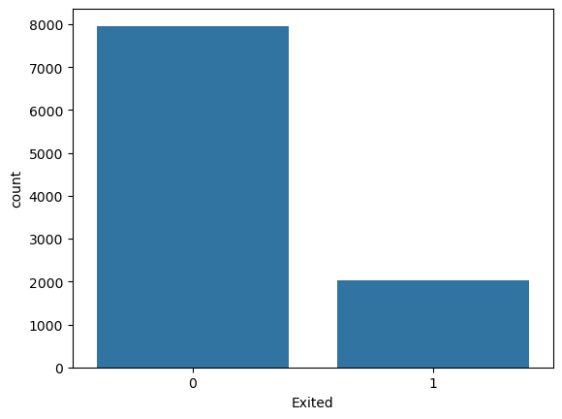
The target variable is:
- Exited = 1 → Customer churned
- Exited = 0 → Customer retained
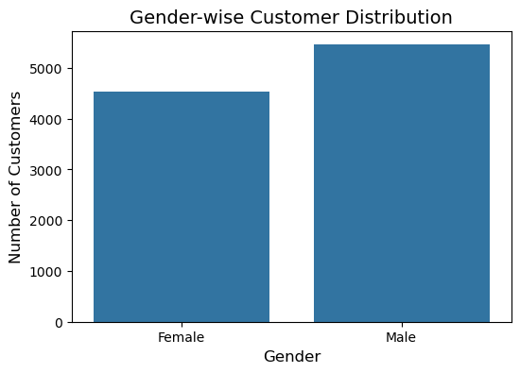
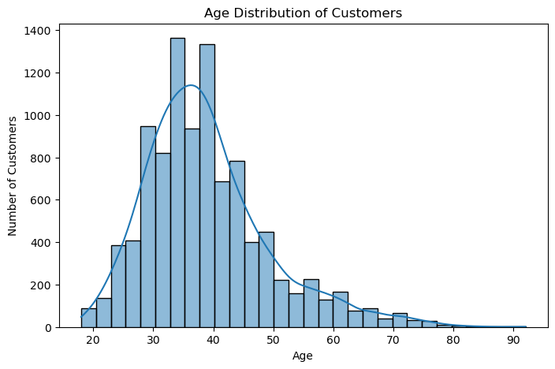

- Research Methodology

- Data Preprocessing
The following preprocessing steps were performed:
- Removal of non-informative columns
- Handling of categorical variables using encoding
- Feature scaling for numerical variables
- Train-test splitting
- Data validation and consistency checks

- Feature Engineering
Additional features were generated to improve predictive performance:
- Balance-to-Salary Ratio
- Product Density
- Engagement-Product Interaction
- Age-Tenure Interaction

- Machine Learning Models
The following machine learning algorithms were implemented:
- Logistic Regression
- Decision Tree
- Random Forest
- Gradient Boosting

- Model Evaluation Metrics
The effectiveness of the machine learning models was assessed through the subsequent metrics:
- Accuracy
- Precision
- Recall
- F1-Score
- ROC-AUC Score

- Explainability and Deployment
To improve model interpretability and practical usability, the following techniques were implemented:
- SHAP (Shapley Additive explanations) Analysis
- Feature Importance Analysis
- Customer-Level Risk Scoring
- Streamlit Dashboard Development
- Real-Time Churn Prediction Interface
Raw Data → Data Preprocessing → Feature Engineering → Model Training → Model Evaluation → SHAP Explainability → Streamlit Deployment
- Exploratory Data Analysis
Exploratory Data Analysis (EDA) was conducted to understand the structure of the dataset, identify significant patterns, examine relationships among variables, and uncover potential factors influencing customer churn. Exploratory Data Analysis plays an important part in making predictions because it gives us useful information about what customers do before we even start making a model. We use Exploratory Data Analysis to understand our customers and Exploratory Data Analysis is very helpful, in this process. Through various statistical summaries and visualization techniques, meaningful trends were identified that helped guide feature engineering and model selection.
The initial analysis focused on understanding the distribution of the target variable, namely customer churn. The churn distribution chart revealed that a majority of customers remained with the bank, while a smaller proportion exited. This imbalance is common in churn prediction datasets and highlights the importance of selecting evaluation metrics beyond simple accuracy.
Customer Demographics Analysis
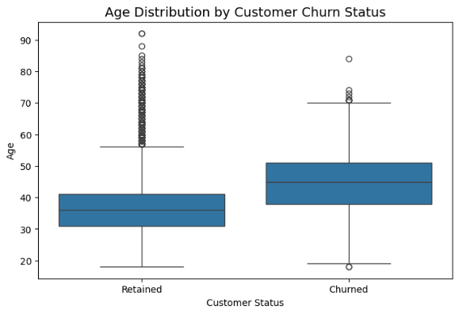
The age distribution histogram indicated that customers were spread across a wide range of age groups, with a significant concentration in the middle-aged segment. Further analysis showed that customers who are older tend to leave often than younger customers. The older customers are more likely to churn. This means age plays a role, in whether customers stay or go. This observation suggests that age may influence customer satisfaction, financial requirements, and banking preferences.

Gender analysis showed that there were equal numbers of male and female customers in the data. The male and female customers were evenly distributed. This balance, between female customers is a good representation. The dataset had a mix of male customers and female customers. While gender alone did not appear to be a dominant churn driver, it remained an important demographic feature for model training and analysis.
Geographic Analysis
Customer churn was further examined across different geographical regions. The analysis showed that people in countries stop using a service at different rates. This means that the way people stop using a service is not the same. The analysis found differences in the way people in different countries behave when they stop using a service, which is also called churn behaviour. The churn behaviour in some countries is really different from the churn behaviour, in countries. Customers from Germany demonstrated comparatively higher churn rates than customers from France and Spain. This pattern may reflect variations in customer expectations, competitive banking environments, or regional economic factors.
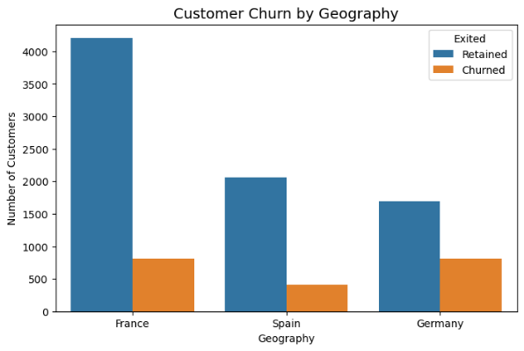

The geographical analysis shows that where customers live really matters for keeping them. Location-based segmentation is a part of customer retention strategies. It helps businesses understand their customers better. They can then tailor their approach to meet needs. This makes customers more likely to stay. Geographical analysis is useful, for finding these location-based insights. It allows companies to target their marketing efforts effectively. By doing they can improve customer retention. Customer retention strategies rely on understanding customer needs. Geographical analysis provides information. It helps businesses make decisions. Location-based segmentation is crucial. It enables companies to deliver experiences. This leads to customer satisfaction. Customers are more likely to stay with a company that understands them. Geographical analysis helps businesses achieve this. Banks may benefit from implementing region-specific engagement programs and customer support initiatives to address localized churn patterns.
Customer Activity and Engagement Analysis
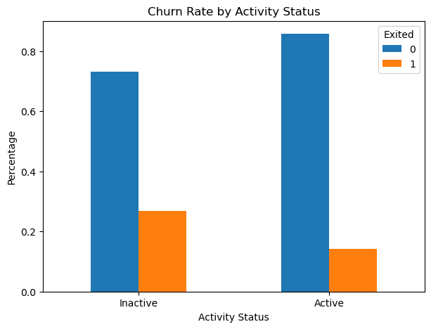
Customer engagement emerged as one of the most influential factors associated with churn behaviour. The activity status analysis revealed that inactive customers were significantly more likely to leave the bank compared to active members. Customers who regularly interacted with banking services exhibited stronger retention rates and lower churn probability.

This finding emphasizes the importance of customer engagement programs in maintaining long-term relationships. When we talk about customer activity regular communication is really important. We should also give customers personalized recommendations that're just for them. Loyalty initiatives are a good idea too. These things can help get customers to do stuff and stop them from leaving. Customer activity is what we want to focus on. We want to keep customers active and happy. So, we need to keep talking to them and give them what they want. This way we can reduce the risk of customers stopping to do business with us, which is called attrition risk. Activity and loyalty initiatives go hand in hand.
Product Utilization Analysis
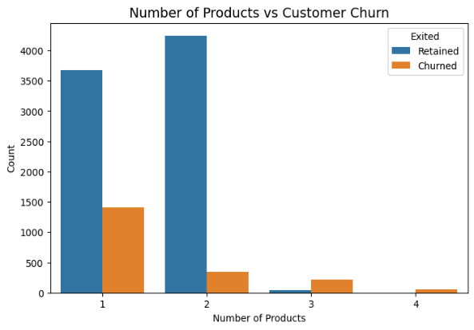
The relationship between product ownership and churn was also investigated. Customers with multiple banking products generally demonstrated lower churn rates than those possessing only a single product. Product ownership reflects the depth of customer-bank relationships and often serves as an indicator of customer commitment.

Customers using multiple services such as savings accounts, credit cards, loans, and investment products tend to be more integrated into the banking ecosystem, making them less likely to switch providers. This thing I noticed says that selling than one thing to customers and having a lot of different products can help keep customers coming back, to the business. The idea of cross-selling and having products can really help with customer retention. Customer retention is very important. This is where cross-selling and product diversification come in.
Financial Characteristics Analysis
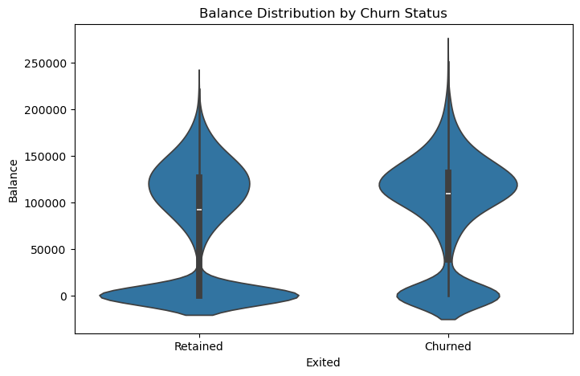
Financial variables such as account balance, estimated salary, and credit score were analysed to understand their influence on churn behaviour. Customers with lower engagement and higher account balances occasionally exhibited increased churn tendencies, suggesting that financial characteristics alone do not fully explain customer retention patterns.

Credit score analysis revealed moderate variation between churned and retained customers. While creditworthiness remains an important customer attribute, behavioural factors appeared to exert greater influence on churn outcomes than purely financial indicators.
Correlation Analysis
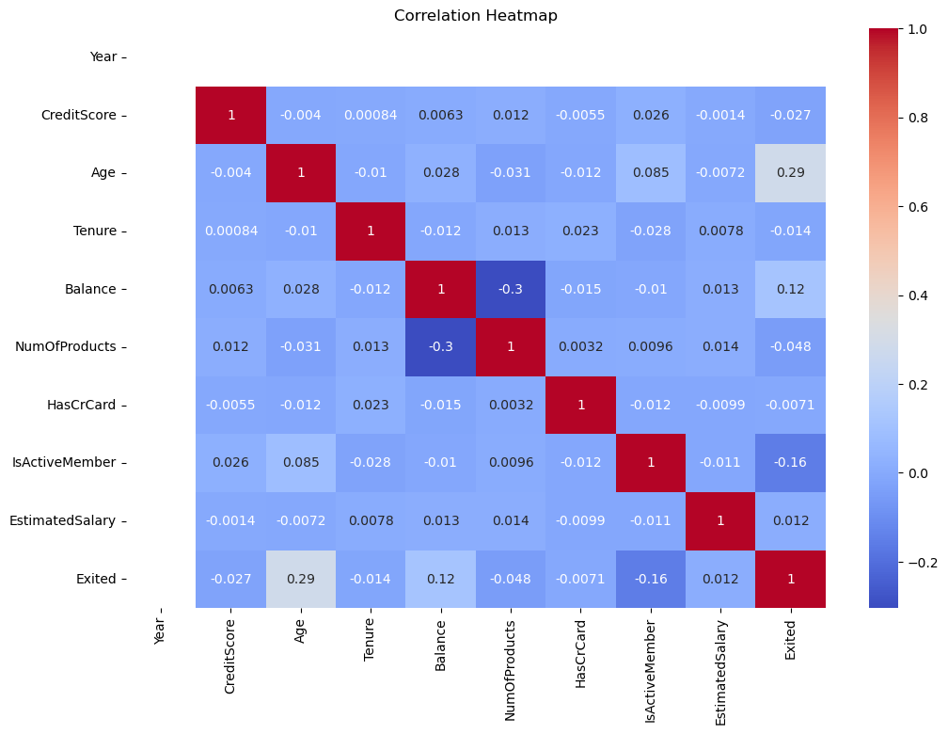
A correlation heatmap was generated to examine relationships among numerical variables. The analysis indicated moderate associations between several features while confirming the absence of severe multicollinearity. The target variable exhibited meaningful relationships with customer age, activity status, and product ownership.

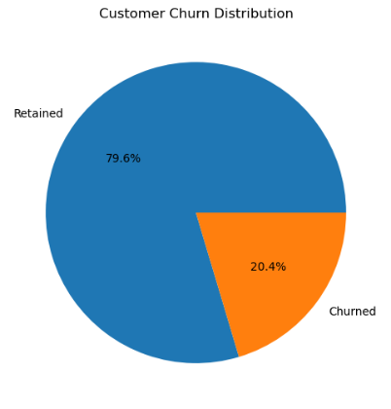
Overall, the exploratory analysis demonstrated that customer churn is influenced by a combination of demographic, behavioural, and financial factors. Among all variables examined, customer engagement, activity status, age, and product utilization emerged as the strongest indicators of churn risk. These insights provided valuable guidance for feature engineering and predictive model development in subsequent stages of the research.

- Model Evaluation
The models were evaluated using:
- Accuracy
- Precision
- Recall
- F1-score
- ROC-AUC Score

Accuracy Comparison
The predictive performance of all machine learning models was compared using accuracy scores. Logistic Regression achieved an accuracy of 81%, while Decision Tree produced the lowest accuracy of 79%. Ensemble learning methods demonstrated superior performance, with Random Forest achieving 86% accuracy and Gradient Boosting achieving the highest accuracy of 87%.
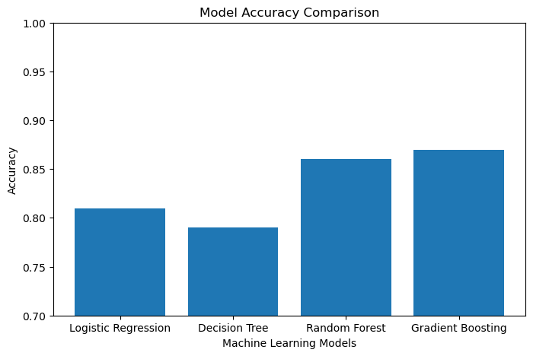

The results indicate that ensemble models are more effective in capturing complex customer behavior patterns and nonlinear relationships within the dataset. Consequently, Gradient Boosting was identified as the best-performing model for customer churn prediction.

ROC Curve Analysis

Receiver Operating Characteristic (ROC) curves were generated to evaluate the classification capability of the implemented models across different threshold values. The ROC-AUC scores indicate the ability of a model to distinguish between churned and retained customers.
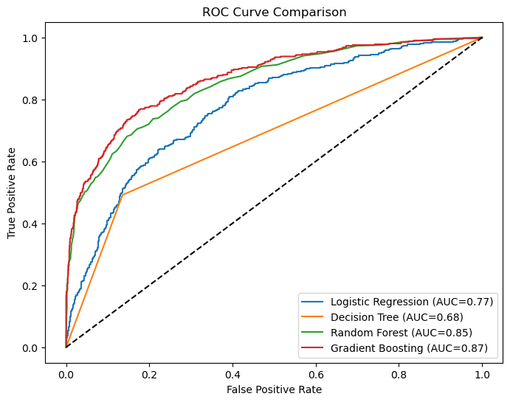
Among all evaluated algorithms, Gradient Boosting achieved the highest ROC-AUC score of 0.87, followed closely by Random Forest with 0.85. The superior ROC performance of Gradient Boosting confirms its strong predictive capability and reliability for customer churn classification.

Confusion Matrix Analysis

A confusion matrix was generated for the Gradient Boosting model to assess classification performance in greater detail. The matrix illustrates the number of correctly and incorrectly classified observations, including true positives, true negatives, false positives, and false negatives.
The results indicate that the model successfully classified the majority of customers while maintaining a relatively low number of misclassifications. This demonstrates the effectiveness of Gradient Boosting in identifying potential churners and supports its selection as the final predictive model.
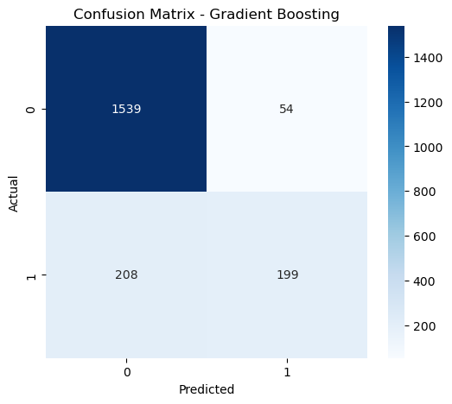

Model Selection
Based on the comparative evaluation, Gradient Boosting emerged as the most effective model, achieving the highest accuracy and ROC-AUC score among all implemented algorithms. Its ability to capture complex relationships within customer data and generate reliable probability estimates makes it particularly suitable for banking churn prediction applications. Therefore, Gradient Boosting was selected for subsequent SHAP explainability analysis and deployment within the Streamlit dashboard.

Model | Accuracy | ROC-AUC
Logistic Regression | 0.81 | 0.78
Decision Tree | 0.79 | 0.68
Random Forest | 0.86 | 0.85
Gradient Boosting | 0.87 | 0.87

Gradient Boosting achieved the best overall performance among all models.
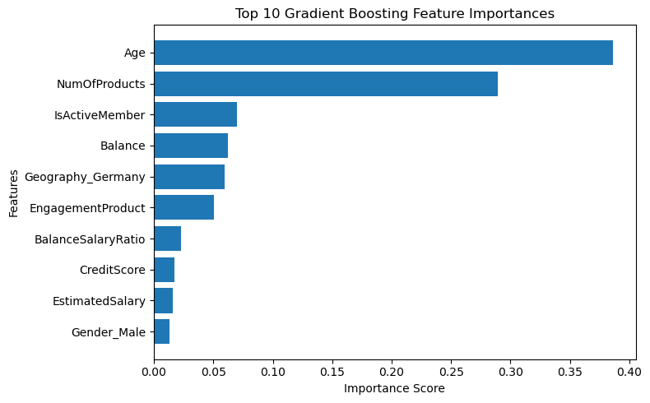

- SHAP Explainability Analysis
While achieving high predictive accuracy is an important objective in machine learning, understanding the reasoning behind model predictions is equally important, particularly in the banking sector where transparency and interpretability are critical. Financial institutions often require explainable decision-making systems to support business strategies and improve stakeholder confidence in predictive models. So we did a SHAP analysis to make the chosen model, for predicting when customers stop using our service easier to understand. We used SHAP, which stands for Shapley Additive explanations to do this. The goal was to make the selected churn prediction model clearer. This model is used to predict churn, which's when customers stop using our service.
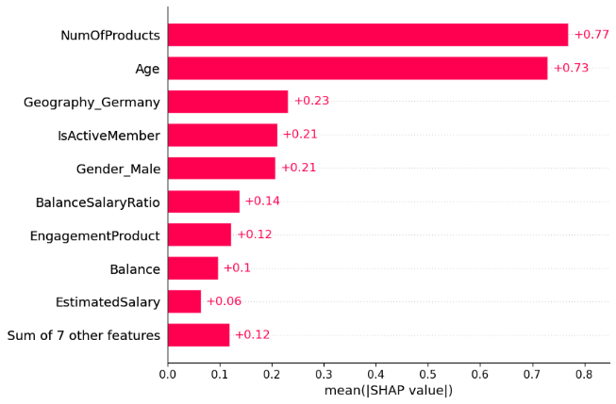
SHAP is an explainable artificial intelligence (XAI) framework based on cooperative game theory. It assigns a contribution value to each feature, indicating how much that feature influences the final prediction. Unlike traditional feature importance techniques, SHAP provides both global and local explanations, enabling a deeper understanding of model behaviour.

Global Feature Importance
A SHAP summary plot was generated to identify the most influential variables affecting customer churn predictions. The analysis revealed that customer age had the strongest impact on churn probability. Older customers generally exhibited higher churn risk compared to younger customers. This finding aligns with the exploratory data analysis and suggests that customer preferences and banking requirements may change with age.
Customer activity status emerged as another highly significant predictor. Inactive members consistently demonstrated higher churn probabilities, indicating that customer engagement plays a vital role in retention. Customers who actively utilize banking services are more likely to maintain long-term relationships with the institution.
The number of products owned by a customer also showed substantial influence on churn behavior. Customers with multiple banking products exhibited lower churn probabilities, highlighting the importance of cross-selling strategies in strengthening customer loyalty.
Additional factors such as account balance, tenure, and credit score contributed to churn predictions, although their influence was comparatively lower than behavioral variables.
Local Prediction Interpretation
One of the key advantages of SHAP is its ability to explain individual predictions. For example, a customer classified as high-risk may have received a high churn probability due to a combination of advanced age, inactive membership status, and ownership of only a single banking product. SHAP values clearly illustrate how each feature contributed to the final prediction score.
This capability enables banking professionals to understand why a particular customer is considered at risk and supports the design of targeted retention interventions. Rather than treating all churn-prone customers similarly, banks can develop personalized engagement strategies based on the specific factors driving churn risk.
Business Significance
The integration of SHAP analysis significantly improves the practical applicability of the proposed churn prediction system. Beyond providing accurate predictions, the model offers transparent explanations that can support managerial decision-making. Banking executives can find out what makes customers leave focus on keeping them and create plans to engage with customers based on data. They can identify things that make customers switch to another bank. Customer attrition is a problem so they prioritize keeping customers. Data helps them make plans to engage with customers. Banking executives use data to develop customer engagement strategies. They want to keep customers happy and engaged with their bank.
Overall, SHAP analysis confirmed that behavioral factors such as customer activity and product utilization exert a stronger influence on churn than many traditional demographic variables. These insights demonstrate the value of explainable artificial intelligence in enhancing trust, transparency, and business understanding within predictive analytics applications.

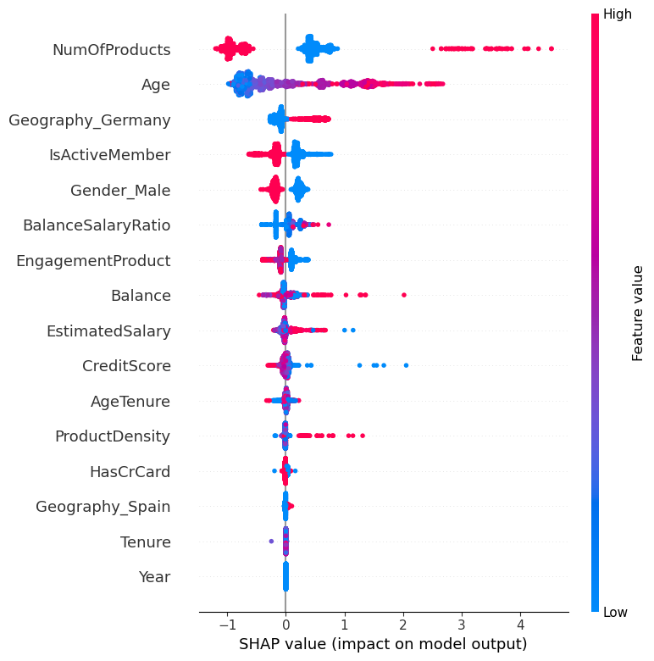
SHAP analysis enhanced model transparency and business interpretability.

- Streamlit Dashboard Development
To enhance the practical usability of the proposed churn prediction system, an interactive web application was developed using Streamlit. While machine learning models can effectively predict customer churn, their business value increases significantly when decision-makers can access predictions through a user-friendly interface. The Streamlit dashboard was designed to bridge the gap between predictive analytics and real-world banking applications.
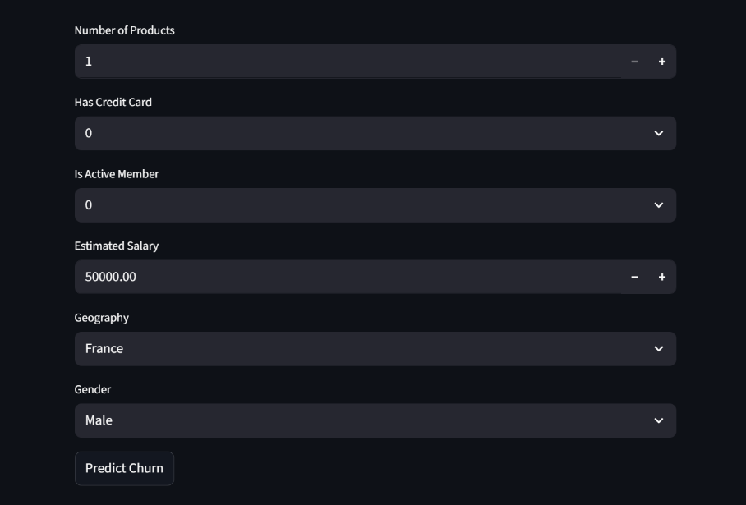
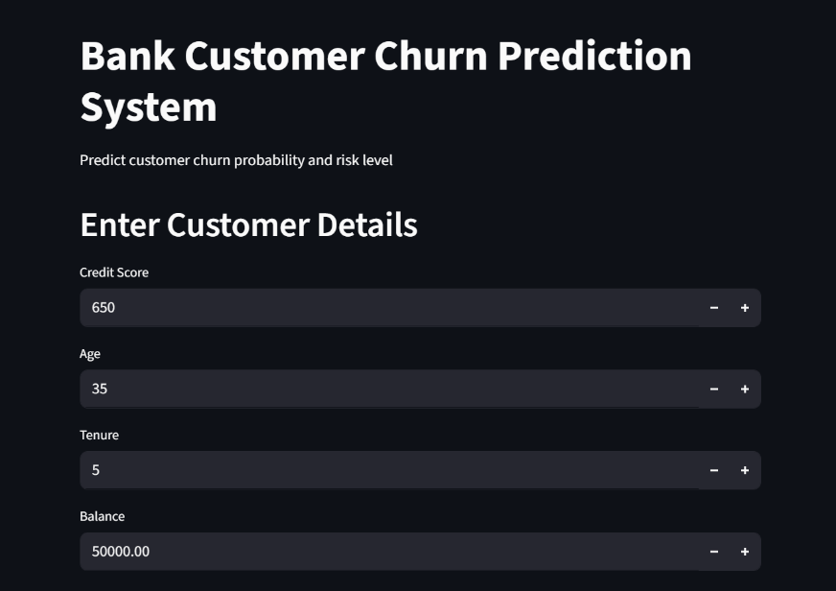
The dashboard allows users to input customer information including credit score, age, geography, tenure, account balance, number of products, activity status, and estimated salary. Based on the entered values, the trained Gradient Boosting model generates a churn probability score and classifies the customer into an appropriate risk category.

The application categorizes customers into three risk segments:
- Low Risk
- Medium Risk
- High Risk
This risk-based classification enables banking professionals to prioritize retention efforts and allocate resources more effectively. Customers identified as high-risk can be targeted through personalized communication, loyalty programs, special offers, or dedicated customer support initiatives.
In addition to churn prediction, the dashboard provides visual representations of model outputs to improve interpretability and decision-making. Users can explore customer scenarios by modifying input values and observing corresponding changes in churn probability. This interactive functionality supports business experimentation and strategic planning.
The deployment of the model through Streamlit demonstrates how machine learning solutions can be transformed from analytical tools into operational decision-support systems. By providing real-time predictions and intuitive visualizations, the dashboard enhances the accessibility and practical implementation of churn intelligence within banking environments.
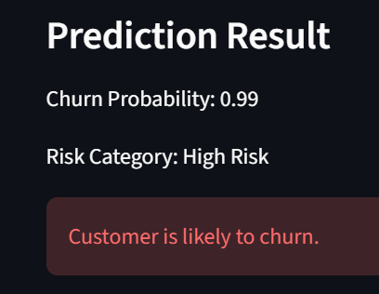
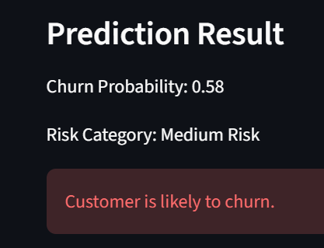
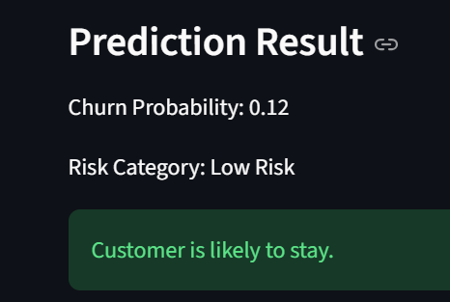
The dashboard serves as a practical demonstration of how predictive analytics can support proactive customer retention and data-driven banking strategies.

- Findings and Insights
The analysis conducted throughout this research identified several important factors influencing customer churn behavior within the banking sector. The findings demonstrate that customer attrition is not driven by a single variable but rather by a combination of demographic, behavioural, and financial characteristics.
One of the most significant findings is the strong relationship between customer engagement and churn. Customers classified as inactive members consistently exhibited higher churn probabilities than active customers. This observation suggests that customer engagement plays a crucial role in maintaining long-term banking relationships. Banks that really want customers to interact with them through things like services and special messages just for them and also have rewards programs may be able to keep more customers. Banks do this to make customers happy and stay with them. Banks with digital services and loyalty programs are good, at keeping customers.
Age emerged as another important determinant of churn behaviour. The analysis revealed that older customers generally displayed higher churn tendencies compared to younger customers. This finding may indicate changing financial needs, service expectations, or competitive influences across different age groups.
Product ownership was also found to significantly affect customer retention. Customers possessing multiple banking products demonstrated lower churn rates than customers using only a single product. This result highlights the importance of cross-selling strategies and integrated financial services in strengthening customer loyalty.
Geographical analysis indicated notable differences in churn behaviour across regions. Customers from Germany had a rate of leaving than customers from other countries in the data. This was especially true for Germany. Customers from countries did not leave as often. The data showed that Germany had a problem with customers leaving. Customers from Germany left at a rate. This was clear, from looking at the data. It showed Germany stood out for having customers leave often. Such findings suggest that regional market conditions and customer expectations may influence retention outcomes.
From a modelling perspective, ensemble learning algorithms significantly outperformed traditional classification approaches. Gradient Boosting achieved the highest predictive performance, indicating its effectiveness in capturing complex relationships among customer attributes. The SHAP explainability analysis showed that the status of customer activity the age of customers and how customers use products are important things to consider when the bank is trying to figure out which customers will stop doing business with the bank. The status of customer activity and the age of customers and how customers use products all play a role in this. When the bank is looking at the SHAP explainability analysis they can see that the status of customer activity and the age of customers and how customers use products are things to look at to understand which customers will stop doing business with the bank.
The results of the study show that using analytics is a way to get information that can help banks keep customers and make smart decisions. Banks can really benefit from this especially when it comes to the banking industry. The banking industry can use analytics for customer retention management. To make smart decisions at banks. The banking industry is about making good choices and keeping customers happy so analytics is very useful, for the banking industry.

- Conclusion
Customer churn remains one of the most significant challenges faced by modern banking institutions due to its direct impact on profitability, customer lifetime value, and long-term business sustainability. As competition within the financial services sector continues to intensify, banks increasingly require proactive approaches capable of identifying at-risk customers before actual attrition occurs.
This research successfully developed a machine learning-based predictive churn intelligence system designed to identify customers likely to discontinue their relationship with a bank. Multiple classification algorithms, including Logistic Regression, Decision Tree, Random Forest, and Gradient Boosting, were implemented and evaluated using standard performance metrics. The comparative analysis demonstrated that Gradient Boosting achieved the highest predictive performance, making it the most suitable model for customer churn prediction within the scope of this study.
The research further incorporated feature engineering techniques and SHAP explainability analysis to improve both predictive capability and model transparency. The results revealed that customer age, activity status, and product ownership were among the most influential factors affecting churn behaviour. These insights provide valuable guidance for banking institutions seeking to develop targeted customer retention strategies.
An interactive Streamlit dashboard was also developed to facilitate real-time churn prediction and customer risk assessment. The dashboard demonstrates how predictive analytics can be integrated into practical decision-support systems, enabling banking professionals to identify high-risk customers and implement proactive retention measures.
The findings of this study confirm that machine learning and explainable artificial intelligence can significantly enhance customer churn management within the banking sector. By leveraging predictive analytics, banks can improve customer retention, optimize marketing efforts, and strengthen long-term customer relationships.
Future Scope
Although the proposed system achieved strong predictive performance, several opportunities for future enhancement remain. In the future researchers will probably look at real-time transaction data and customer interaction histories to get an idea of what people will do. They will also use analytics to make their predictions more accurate. This will help them understand the customers and the transactions better. Research that is going to happen in the future will for sure use real-time transaction data to make our predictions better. We will use real-time transaction data to improve the way we do things. Future research will use real-time transaction data to make things more accurate. Advanced deep learning techniques such as Artificial Neural Networks (ANNs), Long Short-Term Memory (LSTM) networks, and hybrid ensemble models may also be explored.
Additionally, future systems could integrate automated retention recommendation engines capable of suggesting personalized interventions for individual customers. Such advancements would further strengthen the practical value of predictive churn intelligence and support more effective customer relationship management in modern banking environments.

- References

- Varsha Agarwal, Shwetkranti Taware, Suman Avdhesh Yadav, Durgaprasad Gangodkar, A. L. N. Rao, and V. K. Srivastav. Customer-Churn Prediction Using Machine Learning. IEEE International Conference on Technological Advancements in Computational Sciences (ICTACS), 2022.
- Sun Dao, Tao Dong, and Sarah Chen. Automated Customer Churn Prediction in Banking: A Domain-Aware AutoML Approach. 2026.
- A. Coser, A. Aldea, and M. M. Maer-Mate. Propensity to Churn in Banking: What Makes Customers Close the Relationship with a Bank?
- Ruchika Bhuria, Sheifali Gupta, Upinder Kaur, Salil Bharany, Ateeq Ur Rehman, Seada Hussen, Ghanshyam G. Tejani, and Pradeep Jangir. Ensemble-Based Customer Churn Prediction in Banking: A Voting Classifier Approach for Improved Client Retention Using Demographic and Behavioral Data.
- Awais Manzoor, M. Atif Qureshi, Etain Kidney, and Luca Longo. A Review on Machine Learning Methods for Customer Churn Prediction and Recommendations for Business Practitioners. IEEE, 2024.

- Software and Tools Used

• Python
• Jupyter Notebook
• Anaconda Navigator
• Streamlit
• Anaconda prompt
• SHAP

